L2 or L3 or tests name: Cyber and IS Strategy and Design
Legal entities in scope: DBAG, ExR, EFAG, ECAG, CBF, CH, CBL, LuxCSD, CI, CS, CFCL and ECC/EEX
Cyber and IS Strategy and Design
(+covers AU-121-04-CSDR Cyber & IS)

Test(s) according to RCA:
Reference to DORA Chapter 2, Article 6 (Para 8) and 7.

(TP1) IA to check SII 2024-040_F04 status: - Outdated IS documentation in Level 4 and Level 5 (SII from previous audit 2024-040 Cyber and IS audit. CLOSED as per AMIT tool (AMIT-807).
(TP2) IA to check SII 2024-040_F05 status: - Cloud Security Guideline overdue annual update and review (SII from previous audit 2024-040 Cyber and IS audit).

(TP3) IA to follow up on the “Information Security Organization Guideline, Level 4, V1.0” (Hint: The guideline was last reviewed in 2021- to assess if it still relevant and why it has not been reviewed /aligned with DORA requirements. (Owner of document: Head of Information Security Framework & Governance))

(TP4) An ICT Risk Management Framework (Version 1.0) is in place since December 2024 which includes the second level documents (the ICT Risk Guidelines) subordinate to the ICT Risk Policy –integrating the IS and IT frameworks into one framework that also incorporates relevant DORA requirements. Areas to be checked:
a) Verify the existence of ICT Risk related procedures (Hint: As per the 2024 ICT Risk Framework, ICT risk related procedures will be addressed separately- Have those procedures already been rolled out- unclear at this stage since they are not available on the Intranet?)
b) Review sample of written rules (guideline, procedure) relating to IS (E.g. vulnerability management, incident management, change management, ICT Risk Management) to ascertain adherence to regulatory requirements (DORA, CSSF)

(TP5) Framework Alignment, Measurement and Monitoring. Areas to be checked:
a) Follow up on FuN: 250312133836 – The new ICT Risk Management Policy (Version: 1.0, Valid from 01.01.2025, prepared by DBAG CICTRO/CISO) and the Digital Operational Resilience Strategy (Version 1.0, 13.12.2024) focus strongly on Risk Management (to manage and mitigate cyber & InfoSec threats) but may be does not support and articulate the Cyber & IS Strategy and Design. Reference to DORA Chapter 2 Article 6 para 2), IA to check if 2LoD (Line of Defense) in its ICT risk management framework included “Cyber & IS Strategy and Design” within strategies, policies, procedures, ICT protocols and tools that are necessary, to ensure that all information assets and ICT assets are adequately protected from risks including damage and unauthorized access or usage. Also, check if “Cyber & IS Strategy and Design” serve the 1LoD functions as a basis for implementing Cyber & IS related processes.
b) Confirm that the DOR strategy aligns with other relevant frameworks and policies (Group Risk Framework, CIO/COO IT Strategy, Cyber Resilience Strategy). Check for consistency and cross-references.
c) Verify that appropriate (SMART) metrics are defined and in place measure the effectiveness of the DOR & Cyber Resilience strategy and implementation initiatives. Check the frequency of reporting and how the results are used for improvement. Verify the coverage for all DBG LEs in audit scope.

Audit procedures/source:
- Information directly requested from auditee (via e-mail or call) or extracted from provided documentation during preparation phase.

Conclusion: No issue for close-out list.
Extra Check – one issue regarding Partner Services – a follow up of audit comment from 2024-063 Technology Governance - Partner Services: Inadequate guidelines on Partner Services as asset type in DBG’s APMS (2025-045_F05)

Internal audit (YG, UE) has performed the following Audit procedures:

-------------------------------------------------------
Summary of work done:
-------------------------------------------------------

AP | Work done | Result
TP1 | IA noted that following Guidelines were updated according to the AMIT-807:  - DBG_GS_DLP Guideline v2.0  - DBG_GS_Data_Security_Guideline v1.1  - DBG_GS_Anti-Malware Guideline v1.2  - DBG_GS_Vulnerability Management Guideline_v3.0  - DBG_GS_Baseline Security Guideline v1.5  - DBG_GS Secure Software Development Guideline  - DBG_GS_Penetration_Test_Procedure_v1.0  The SII 2024-040_F04, which was raised by Cyber Protection and Automation (IFB), is now closed. However, IA noted that Group Security Guidelines are still under review regarding the new ICT Risk Management Framework. These updates are being tracked in the ongoing DORA project through 2025 and in the open S3 Finding – 2024-063_F01 CAP. Currently, this activity has not been finalized, and the procedural documents of the Group Security Teams have not been updated.  Ok, no exception identified. | OK
TP2 | On May 30, 2025, IA held a meeting with Julian Wiegmann (Head of Strategy & Architecture), the owner of SII, and was informed that the document previously called Cloud Security Guidance has been decommissioned. For this reason, responsibility for the Cloud Security area has been handed over to the relevant teams, taking into account procedures such as IAM, PAM, and Data Security. (evidence)  Ok, no exception identified. | OK
TP3 | IA has been informed that “Information Security Organisation Guideline” has been decommissioned. New ICT Risk Management Policy (version: 1.0) is in use to provide a binding ruleset for Deutsche Börse AG (DBAG) and/ or adopting LEs within Deutsche Börse Group (DBG) manage and oversee ICT risks, with a focus on digital and operational resilience. (evidence)  Ok, no exception identified. | OK
TP4 | - IA has been informed that ICT Risk Framework is responsible for the update of ICT Risk guidelines (2LoD, previously Standards). Related procedures will be reviewed, updated accordingly by the 1st LoD as they are the owners of those documents. IA obtained the 1LoD - Group Security docs. (Group Security’s Sharepoint for Guidelines)  - IA observed that the 2nd LoD guidelines were completed and published in January 2025, including the new ICT framework. IA was informed that the 1st LoD Procedures will be updated in 2025 to reflect the new written rules framework. These updates are being tracked in the ongoing DORA project through 2025 and in the open S3 Finding – 2024-063_F01 CAP. Currently, this activity has not been finalized, and the procedural documents of the Group Security Teams have not been updated. Naming and referencing ICT and DORA are lacking. The deadline for finalizing the first level of documents is end of 2025.  IA had a meeting with 2LoD ICT Risk Management team (Sarah Ahmad Jahn- Head of ICT Risk Framework and Petr Strnad- Head of IT Risk & Controls) on July 7, 2025 and had been informed that KRIs for the selected guidelines are on track and written guidelines are covering new DORA ICT Risk Framework. The first level of defense (1LoD) implements its controls in the procedures by contacting the second level of defense (2LoD).  Additionally, IA noted the following details in the sampled 2LoD Guidelines:  IAM Guideline: The guideline comprehensively covers access request procedures, account lifecycle management, access rights definition and documentation, segregation of duties (SoD), and account recertification. Also, it addresses password management, strong authentication (including multi-factor authentication), and protection against unauthorized access.  Software Development and ICT Change Management Guideline: The guideline details the ICT change management process, covering documentation, classification, prioritization, authorization, approval, testing, and implementation. This detailed approach addresses DORA's focus on controlled and systematic change management.  The guideline incorporates security throughout the software development lifecycle (SDLC), including secure coding, secure system architecture, source code testing, and security function testing.  Network Security Guideline: The guideline mandates secure configuration and hardening baselines for network and infrastructure components, along with regular reviews, which is a crucial element of operational resilience under DORA. The guideline explicitly addresses network segregation and requires implementing different network security zones logically and recommends a clear perimeter for each zone. It mentions DMZs and separate networks for administration, aligning with DORA's expectations for environment separation to limit the impact of security breaches.  ICT Incident Operational Event Management Guideline: The guideline defines comprehensive rules and procedures for managing ICT incidents, including identification, logging, analysis, response, and reporting, aligned with DORA’s requirements for a robust incident management framework. The definition of early warning indicators shows a proactive approach. The detailed logging procedures, including retention periods and security measures for log data, fulfill DORA's expectations for comprehensive logging and analysis of security events. The inclusion of "lessons learned" is a positive for continuous improvement. (Note: IA noted that ICT Incident Guideline references control from DORA Chapter 3 - ICT-related incident management (Articles 17-19) and therefore no issues.)  Ok, no exception identified. | OK
TP5 | - IA obtained the ICT Risk Management Policy and Digital Operational Resilience Strategy documents.  In the DOR Strategy document, it was mentioned that “Strategy is aligned with (but not limited to) the Group Risk Framework, CIO/COO IT Strategy, DBAG Outsourcing & TPRM Strategy, and DBAG Cyber Resilience Strategy”.  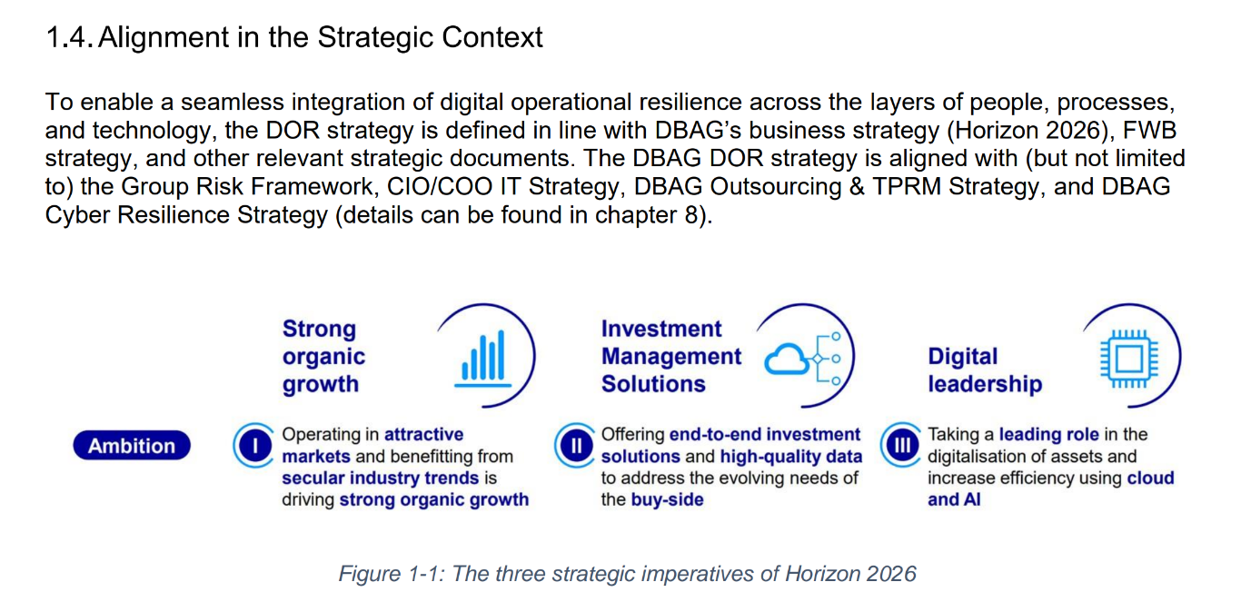  IA held a meeting on 11.06.2025 with Sarah Ahmad Jahn (Head of ICT Risk Framework) and Christian Goetz (Head of ICT Risk Strategy & Methodology). IA had been informed that within the new ICT Framework of DBG, 2nd LoD Guidelines, CIO/COO IT Strategy, and DBAG Cyber Resilience Strategy, serve to 1LoD functions as a basis for implementing Cyber & IS related processes.  b) To confirm that the DOR strategy aligns with other relevant frameworks and policies IA obtained the Group Risk Framework, 2024 CIO/COO IT Strategy and Cyber Resilience Strategy. During the fieldwork, IA has been informed that the 2025 CIO/COO IT Strategy document is not finalized due to dependency on other strategy initiatives within the group. Therefore, date for finalization and approval is tentatively for end of July 2025.  IA observed that the CIO/ COO IT Strategy 2024 document outlines the strategic perspective of information technology to deliver the DBG Strategy “Horizon 2026”. The CIO/ COO division acts as agent for the business with the overall goal to deliver stable operations and availability while implementing growth initiatives in time, scope, quality and budget. In addition, the CIO/ COO division complies with the regulations applicable to regulated entities within the scope of services provided to these entities.  IA observed that DOR Strategy document provides a comprehensive outline of DBAG's approach to enhancing its digital operational resilience. This strategy articulates DBAG's risk appetite in relation to ICT risk to ensure that the approach to digital operational resilience is not only strategic but also aligned with the overall risk management of the group. Also, IA observed that primary objective of establishing digital operational resilience is the protection of stability and continuity of critical or important functions (CIF), which are vital to DBAG’s ability to deliver its products and services to the market.  For the strategy, integration of digital operational resilience across the layers of people, processes, and technology, the DOR strategy is defined in line with DBAG’s business strategy (Horizon 2026), FWB (Frankfurter Wertpapierbörse) strategy, and other relevant strategic documents. The DBAG DOR strategy is aligned with (but not limited to) the Group Risk Framework, CIO/COO IT Strategy, DBAG Outsourcing & TPRM Strategy, and DBAG Cyber Resilience Strategy. (pg. 5 of the DBAG DOR Strategy)  DOR objectives are directly derived from the strategic vision, building on DBAG’s established resilience capabilities. The objectives focus on ensuring confidentiality, integrity, availability, and authenticity of information and the resilience of operations, even in the face of ICT threats, technological failures, or other disruptions. They outline the target state for digital operational resilience at DBAG as informed by the business strategy and ongoing resilience in a dynamic operational landscape while achieving timely compliance with regulatory requirements.  On the Chapter 5 of the Cyber Resilience Strategy describes the security initiatives which are taken to increase the maturity of cyber resilience. The mentioned initiatives are either:  - Separate programs / projects like Hyperion, Ameli, DORA which have their own tracking, reporting, and governance structure (steering committees), which ensure that measures are implemented effectively  - Relevant security services provided by Group Security are already regularly reported with KPI figures as part of the monthly Digital Security Committee (DSC). (evidence)  c) IA observed regarding DOR Strategy that ICT Risk Strategy & Methodology have defined DOR metrics which are used to monitor progress and effectiveness of the objectives and target capabilities described in the Strategy Maintenance and Monitoring Process document. These are monitored and reported on a quarterly basis as part of the CISO Risk Report. First Pilot Reporting was done for Q1 2025. (CISO Risk Report Q1 2025, email distribution)  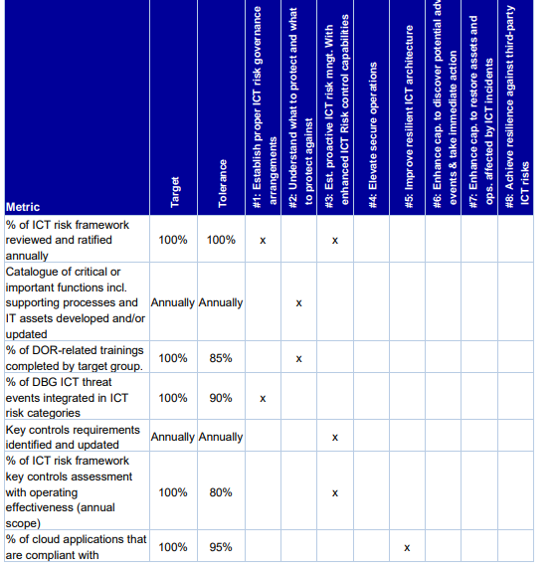  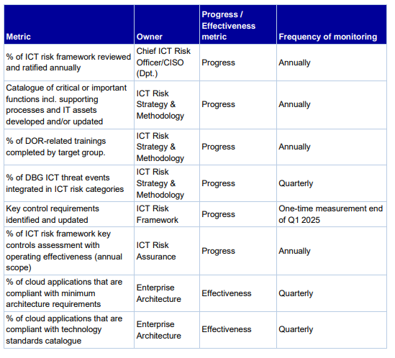  According to the Q1 CISO Risk Report, IA observed that two metrics did not meet their targets, and three metrics are still in development:  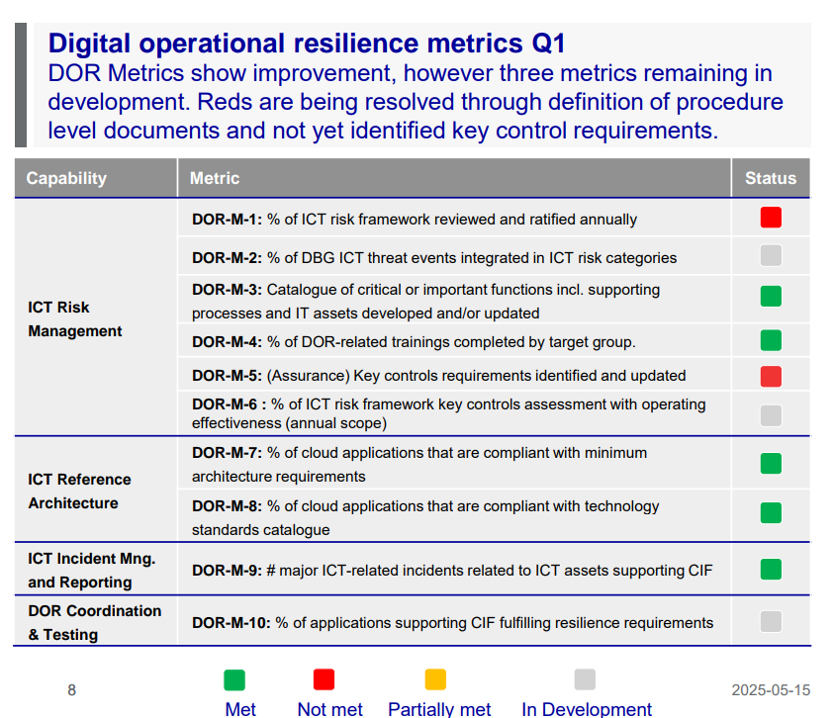  (Note: IA performed controls from DORA Chapter 2 - ICT risk management (Articles 5-10 & 13)) and observed that requirements were taken into accounts in the relevant documents/ guidelines and no issues were found.)  Given that the DORA project is in the implementation phase and tracked closely by the DORA Program in consultation with regulatory bodies – BaFin and CSSF on alternate month basis, and the ongoing remediation of the S3 CAP – 2024-063_F01 finding, IA will not raise this as a finding.  Ok, no exception identified. | OK

Partner Services: Inadequate guidelines on Partner Services as asset type in DBG’s APMS
(2025-045_F05)

An audit comment 5.3 raised in 2024-063 Technology Governance noted Deutsche Börse Group’s (DBG) Application Portfolio Management System (APMS) was incomplete regarding external web assets/services, which IA provisionally designated as “Partner Services”. A feasibility assessment about introducing Partner Services as a new asset type was to be completed by December 2024, its definition included within the ICT Asset Management Guideline v1.0 and control requirements established in the Mandatory Control Framework (MCF).

IA noted that DBG’s APMS inventory did not yet include Partner Services. 2nd LoD - ICT Risk Framework (KJU) and 1st LoD - IT Core Process Design & Operations (ÜPÜ) were still developing clear definition, control requirements and process descriptions. KJU plans to put in force a fully revised ICT Asset Management Guideline v1.1, including the definition of Partner Services, by end of Q3 2025.

German and Luxembourg regulations require financial institutions to maintain accurate and complete inventories of IT assets, including third-party related assets.

From Col panel held on 22 July - Col v1.0, Col v2.0 and Col v3.0

- Three Open topics [A1, A2 and B] from CoL – not for inclusion in the audit report:
As per CoL Panel held on 15 July, AiC was pursing root cause analysis – regarding the topic, Application Owners of 2 applications (out of total 6) erroneously reported cryptographic measures as compliant in respective risk assessment.

[A1] For this IA discussed with Group Security – 1LoD
ISRM team -
1LoD ISRM team provides review and QA of the assessments by the Asset Owner, who is accountable for providing accurate information. In case of non-compliances, then the Asset Owner approves (L1 approval), before submitting for acknowledgement (L2 approval) to the Legal Entities. ISRM checks for field completeness and if non-compliances are supported with remediation actions.

As per ISRM, to the applicable MCF controls as per asset type, it is merely impossible to manually verify the correctness of all input fields provided by Asset Owners and ask for supporting evidence. For this to be automated, ISRM has ongoing initiatives to digitalize using references and feeds from multiple data points. As of today, from IA finding view – there is no central solution that captures the applied cryptography measures and so a data point cannot be referenced or mapped.

045 IA opinion - to have reasonable assurance around the topic - in the ongoing /future business audits, as part of ITGC for critical/major applications – IT auditors to check with asset owners if cryptography controls were applied and validate evidence.
Only if IA observe multiple similar findings on missing measures or incorrect compliance to these controls, a discussion may be re initiated with ISRM in the direction of automated data feeds from a central data point. (Similar to multiple instances of SoD / AC related findings)

23 July:
2 Findings raised to Asset/Application Owners for documenting incorrect compliance to cryptography controls. It’s agreed with respective auditee. One finding is to be closed in 2 weeks with ongoing CR implementation.
IT SFV brainstorming - To improve the quality ISRM is undertaking ‘digitalized integration’ initiatives under the AMELI Program – Currently, the design is under SFV validation with IA. A cue from this audit is passed to IT auditors validating the topic.

---------------------------------------------------------------------

[A2] Group Security – 2025 Procedures
Basis discussion with Hinrich V.–
GS is working to streamline IS processes and enhance efficiency in line with the new framework. GS plans to subsequently formalise the IS operational documentation (“procedures”) and fulfil control requirements to verify compliance. This is included in the DORA Program. The DORA Program progress is tracked and monitored by appropriate oversight mechanisms, e.g. Steering Committees, Board presentations.
Agreement in DORA Program is for keeping the yearly update cycle (or timelines required for AMELI) for GS related procedures. The 1LoD IS operational documents “procedures” (earlier called guidelines from 2023-24) are still valid until the (new) procedures are completed (in alignment to new framework) as per annual review cycle (due in Q3/Q4 2025).

Supporting evidence to be received Wednesday, 23 July.
045 IA opinion – basis the evidence, the topic will be concluded.

23 July: Evidence received (link) and OK – IA Conclusion: A statement on the subject may be included within the Executive Summary. (Refer Sec 3 i, bullet 3 for para to be included in Exec Summary)

[B] For this IA discussed with CISO – 2LoD
ICT Risk Framework (KJU) –
Referencing 2 (above) - Basis IA discussion with Sarah A.J. and Christopher S. –
“Generally, we would expect 1st LoD Procedures to be updated without undue delay after new 2nd LoD Guidelines have been published. At present, there's no formal timeline for this. It may be beneficial to establish a group-wide timeline for all policy frameworks within DBG.”

The “Guidelines v1.0” were published group-wide in January 2025.
The “Guidelines v1.1” is to be published group-wide in mid-August 2025.
And probably “Guidelines v1.2” is to be published group-wide in December 2025 or by Q2 2026.

As per IA notes with Group Security (Hinrich V.), the IS “procedures” will be updated (to align with Guidelines) as per annual review cycle in 2025. Meaning that, the ongoing updating of IS procedures due by Q3/Q4 will only be aligned to Guidelines v1.0, whereas the Guidelines would already be revised to v1.2 in mid-August. This will account for 1LoD efforts to continuously update their procedures to be aligned with Guidelines version. Otherwise, an annual review cycle will have the procedures insufficiently aligned.
See below table for simplified explanation -
2LoD Guidelines | Release date | 1LoD Procedures | Release Date
V1.0 | 17 January 2025 | GS - Multiple – keeping annual review cycle (underway) | August to November 2025
V1.1 | Planned mid-August 2025
V1.2 / V1.3 | -TBC- probably Dec 2025 / by Q2 2026 | GS - Multiple – keeping annual review cycle (in view) | Q3/Q4 2026

Therefore, a need for 2LoD to define a reasonable “formal timeline” and provide guidance to 1LoD for updating their procedures in alignment with 2LoD “Guidelines” is imperative.
045 IA opinion – ongoing discussion with KJU. IA is checking if a “formal timeline” was already considered to be included for next version release (v1.1) in mid-August or the v1.2 in December 2025/Q2 2026.

Wed, 23 July:
Potential finding # 9 - draft added to the CoL v2.0 – dropped*
A discussion with KJU revealed that 1LoD requested to have the Guidelines updated and released at the beginning of H2 2025 to be able to already plan and secure budget in Q3/Q4 2025 for 2026 implementation regarding the added/amended controls.
Also, KJU sees this misalignment of procedures updating to guidelines possibly due to insufficient guidance.

Another call planned with KJU and CISO on Monday, 28 July (11AM) to discuss the idea / roadmap – to possibly include detailed guidance to the group on timelines for updating “procedures” in alignment with published “Guidelines”.

IA Opinion: To make this binding, IA see it as a gap on not providing 1LoD appropriate guidance through “Guidelines” and leaving room for interpretation to 1Lines, allowing them to follow an irregular or unsustainable pattern regarding updating “Procedures”. This may result in a potential finding and if it materializes - will be confirmed in CoL early next week. IA will try to pursue with KJU/CISO in this direction.

*Mon, 28 July:
From Governance and Organizational Services department, as per the Written Rules Framework Guidelines v1.0 (link) - valid from Date: 08. August 2024, its section 4.2.5.1 (page 9 of 14) states
“In general, written rules must be reviewed at minimum on a twelve-month period. The valid-from date within the written rule forms the basis (start date) in which the yearly review must take place. A review by the written rule owner must be carried out promptly and if needed, modifications to the written rules have to be implemented within a reasonable timeframe.”
IA Conclusion: OK (Refer Section 2, table 9)

Procedures / Criteria / documents used:
Links

Caveat: All notes in this document do not represent a protocolary transcript or quotations of the meetings. They would provide an overview over the content of the meeting. Further the notes may be arranged according to the topics discussed and not based on the chronological course of the meeting.

